May Crowning
History
Devotion to the Blessed Virgin Mary began in the earliest days of the Church. May has become known as the month of Mary, most likely because several feasts honoring the Blessed Mother happen during the month of May. Both in the East and in the West the practice of depicting the Blessed Virgin Mary wearing a regal crown came into use in the era of the Council of Ephesus, AD 431. It is especially from the end of the 16th century that in the West the practice
became widespread for the faithful, both religious and laity, to crown images and statues of the Blessed Virgin. We thank you for joining us tonight for our prayer service. During the rosary, we will bring forth different images of the Blessed Virgin Mary used in devotions and cultures across the globe today. We will end in a crowning of the statue of the Blessed Virgin Mary.

Please join us now in singing verse 1 of Immaculate Mary, found on your prayer service sheet.

Immaculate Mary
Verse 1
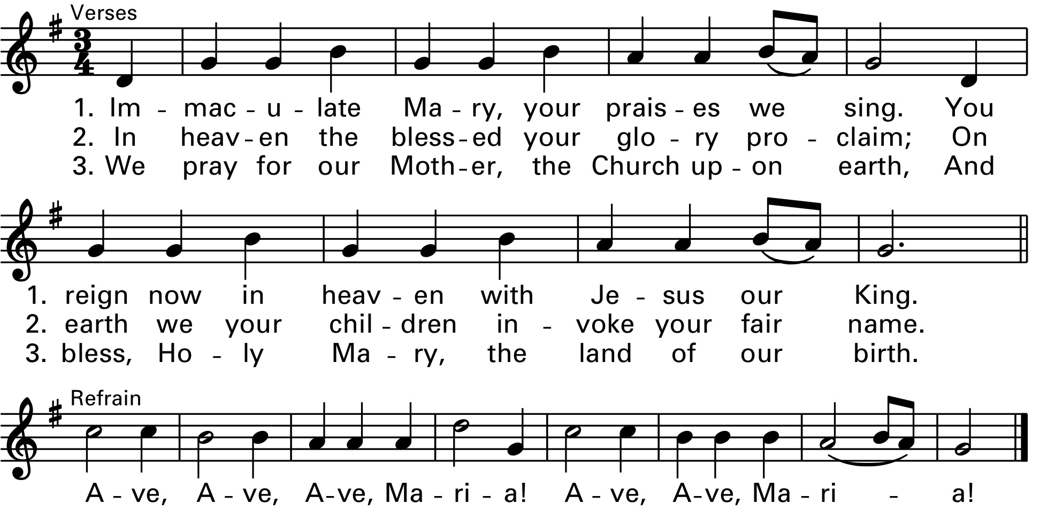

Presider: In the name of the Father, and of the Son, and of the Holy Spirit.
All Respond: Amen.

Presider: Come, let us worship Christ, the Son of Mary.
All respond: Let us give praise and thanks to the Lord as we keep this day in loving memory of the Blessed Virgin Mary.

Introduction
Leader/Pastor: We gather this evening to crown Our Blessed Virgin Mary, the mother of Jesus. As we acclaim Mary, the Mother of God, as our queen and as the Mother of the Church, let us imitate her example in all that we do. As we honor Mary, who is higher than the cherubim and yet like us, let us pray that through her intercession we may achieve holiness of life, and a deepened faith, hope, and love, as we seek to do the will of God in all things. We now turn to Mary in the praying of the rosary, reflecting on the various titles and images of Mary we have today.

Rosary
In the name of the Father +, and of the Son + and of the Holy + Spirit. I believe in God, the Father almighty Creator of heaven and earth and in Jesus Christ, his only Son our Lord, who was conceived by the Holy Spirit, born of the Virgin Mary, suffered under Pontius Pilate, was crucified, died and was buried; he descended into hell; on the third day he rose again from the dead; he ascended into heaven, and is seated at the right hand of God the Father almighty; from there he will come to judge the living and the dead…I believe in the Holy Spirit, the holy catholic Church, the communion of saints, the forgiveness of sins, the resurrection of the body, and life everlasting. Amen.

Our Father
Our Father, who art in heaven, hallowed be Thy name; Thy kingdom come; Thy will be done on earth as it is in heaven……Give us this day our daily bread; and forgive us our trespasses as we forgive those who trespass against us; and lead us not into temptation but deliver us from evil. Amen.

Hail Mary (repeat 3 times)
Hail Mary, full of grace. The Lord is with thee. Blessed art thou among women, and blessed is the fruit of thy womb, Jesus……Holy Mary, Mother of God, pray for us sinners, now and at the hour of our death. Amen.

Hail Mary, full of grace. The Lord is with thee. Blessed art thou among women, and blessed is the fruit of thy womb, Jesus……Holy Mary, Mother of God, pray for us sinners, now and at the hour of our death. Amen.

Hail Mary, full of grace. The Lord is with thee. Blessed art thou among women, and blessed is the fruit of thy womb, Jesus……Holy Mary, Mother of God, pray for us sinners, now and at the hour of our death. Amen.

Glory Be
Glory be to the Father, and to the Son, and to the Holy Spirit……As it was in the beginning, is now, and ever shall be, world without end. Amen.

(Volunteer carries image of Czestochowa)
The First Joyful Mystery, The Annunciation. Mary learns from the Angel Gabriel that God wishes her to be the mother of God and she humbly accepts. Señora de Czestochowa (Chest-uh-cho-uh) help us to say yes to God’s will just as you so humbly chose to do.

Our Father
Our Father, who art in heaven, hallowed be Thy name; Thy kingdom come; Thy will be done on earth as it is in heaven…….Give us this day our daily bread; and forgive us our trespasses as we forgive those who trespass against us; and lead us not into temptation but deliver us from evil. Amen.

Hail Mary (repeat 10 times)
Hail Mary, full of grace. The Lord is with thee. Blessed art thou among women, and blessed is the fruit of thy womb, Jesus……Holy Mary, Mother of God, pray for us sinners, now and at the hour of our death. Amen.

Hail Mary, full of grace. The Lord is with thee. Blessed art thou among women, and blessed is the fruit of thy womb, Jesus……Holy Mary, Mother of God, pray for us sinners, now and at the hour of our death. Amen.

Hail Mary, full of grace. The Lord is with thee. Blessed art thou among women, and blessed is the fruit of thy womb, Jesus……Holy Mary, Mother of God, pray for us sinners, now and at the hour of our death. Amen.

Hail Mary, full of grace. The Lord is with thee. Blessed art thou among women, and blessed is the fruit of thy womb, Jesus……Holy Mary, Mother of God, pray for us sinners, now and at the hour of our death. Amen.

Hail Mary, full of grace. The Lord is with thee. Blessed art thou among women, and blessed is the fruit of thy womb, Jesus……Holy Mary, Mother of God, pray for us sinners, now and at the hour of our death. Amen.

Hail Mary, full of grace. The Lord is with thee. Blessed art thou among women, and blessed is the fruit of thy womb, Jesus……Holy Mary, Mother of God, pray for us sinners, now and at the hour of our death. Amen.

Hail Mary, full of grace. The Lord is with thee. Blessed art thou among women, and blessed is the fruit of thy womb, Jesus……Holy Mary, Mother of God, pray for us sinners, now and at the hour of our death. Amen.

Hail Mary, full of grace. The Lord is with thee. Blessed art thou among women, and blessed is the fruit of thy womb, Jesus……Holy Mary, Mother of God, pray for us sinners, now and at the hour of our death. Amen.

Hail Mary, full of grace. The Lord is with thee. Blessed art thou among women, and blessed is the fruit of thy womb, Jesus……Holy Mary, Mother of God, pray for us sinners, now and at the hour of our death. Amen.

Hail Mary, full of grace. The Lord is with thee. Blessed art thou among women, and blessed is the fruit of thy womb, Jesus……Holy Mary, Mother of God, pray for us sinners, now and at the hour of our death. Amen.

Glory Be
Glory be to the Father, and to the Son, and to the Holy Spirit……As it was in the beginning, is now, and ever shall be, world without end. Amen.

Fatima Prayer
O my Jesus, forgive us our sins, save us from the fires of hell……Lead all souls to heaven, especially those in most need of thy mercy.

(Volunteer carries image of Our Lady of Guadalupe)
The Second Joyful Mystery, The Visitation. Mary goes in haste to visit her cousin Elizabeth and is praised by her as “blessed among women”. Our Lady of Guadalupe help us learn to show love of our neighbor, especially towards all immigrants and those most in need of our help. May we give them the care and compassion you shared with Elizabeth.

Our Father
Our Father, who art in heaven, hallowed be Thy name; Thy kingdom come; Thy will be done on earth as it is in heaven…….Give us this day our daily bread; and forgive us our trespasses as we forgive those who trespass against us; and lead us not into temptation but deliver us from evil. Amen.

Hail Mary (repeat 10 times)
Hail Mary, full of grace. The Lord is with thee. Blessed art thou among women, and blessed is the fruit of thy womb, Jesus……Holy Mary, Mother of God, pray for us sinners, now and at the hour of our death. Amen.

Hail Mary, full of grace. The Lord is with thee. Blessed art thou among women, and blessed is the fruit of thy womb, Jesus……Holy Mary, Mother of God, pray for us sinners, now and at the hour of our death. Amen.

Hail Mary, full of grace. The Lord is with thee. Blessed art thou among women, and blessed is the fruit of thy womb, Jesus……Holy Mary, Mother of God, pray for us sinners, now and at the hour of our death. Amen.

Hail Mary, full of grace. The Lord is with thee. Blessed art thou among women, and blessed is the fruit of thy womb, Jesus……Holy Mary, Mother of God, pray for us sinners, now and at the hour of our death. Amen.

Hail Mary, full of grace. The Lord is with thee. Blessed art thou among women, and blessed is the fruit of thy womb, Jesus……Holy Mary, Mother of God, pray for us sinners, now and at the hour of our death. Amen.

Hail Mary, full of grace. The Lord is with thee. Blessed art thou among women, and blessed is the fruit of thy womb, Jesus……Holy Mary, Mother of God, pray for us sinners, now and at the hour of our death. Amen.

Hail Mary, full of grace. The Lord is with thee. Blessed art thou among women, and blessed is the fruit of thy womb, Jesus……Holy Mary, Mother of God, pray for us sinners, now and at the hour of our death. Amen.

Hail Mary, full of grace. The Lord is with thee. Blessed art thou among women, and blessed is the fruit of thy womb, Jesus……Holy Mary, Mother of God, pray for us sinners, now and at the hour of our death. Amen.

Hail Mary, full of grace. The Lord is with thee. Blessed art thou among women, and blessed is the fruit of thy womb, Jesus……Holy Mary, Mother of God, pray for us sinners, now and at the hour of our death. Amen.
Hail Mary, full of grace. The Lord is with thee. Blessed art thou among women, and blessed is the fruit of thy womb, Jesus……Holy Mary, Mother of God, pray for us sinners, now and at the hour of our death. Amen.

Glory Be
Glory be to the Father, and to the Son, and to the Holy Spirit……As it was in the beginning, is now, and ever shall be, world without end. Amen.

Fatima Prayer
O my Jesus, forgive us our sins, save us from the fires of hell……Lead all souls to heaven, especially those in most need of thy mercy.

(Volunteer carries image of Madonna of the Streets)
The Third Joyful Mystery, The Nativity of Jesus in Bethlehem. Mary gives birth to Jesus in the stable at Bethlehem. Madonna of the Streets give us the strength to fight the temptation to sin and help us detach ourselves from the material things of the world. May we imitate in our own lives the same poverty of Spirit you showed in the Nativity.

Our Father
Our Father, who art in heaven, hallowed be Thy name; Thy kingdom come; Thy will be done on earth as it is in heaven…….Give us this day our daily bread; and forgive us our trespasses as we forgive those who trespass against us; and lead us not into temptation but deliver us from evil. Amen.

Hail Mary (repeat 10 times)
Hail Mary, full of grace. The Lord is with thee. Blessed art thou among women, and blessed is the fruit of thy womb, Jesus……Holy Mary, Mother of God, pray for us sinners, now and at the hour of our death. Amen.

Hail Mary, full of grace. The Lord is with thee. Blessed art thou among women, and blessed is the fruit of thy womb, Jesus……Holy Mary, Mother of God, pray for us sinners, now and at the hour of our death. Amen.

Hail Mary, full of grace. The Lord is with thee. Blessed art thou among women, and blessed is the fruit of thy womb, Jesus……Holy Mary, Mother of God, pray for us sinners, now and at the hour of our death. Amen.

Hail Mary, full of grace. The Lord is with thee. Blessed art thou among women, and blessed is the fruit of thy womb, Jesus……Holy Mary, Mother of God, pray for us sinners, now and at the hour of our death. Amen.

Hail Mary, full of grace. The Lord is with thee. Blessed art thou among women, and blessed is the fruit of thy womb, Jesus……Holy Mary, Mother of God, pray for us sinners, now and at the hour of our death. Amen.

Hail Mary, full of grace. The Lord is with thee. Blessed art thou among women, and blessed is the fruit of thy womb, Jesus……Holy Mary, Mother of God, pray for us sinners, now and at the hour of our death. Amen.
Hail Mary, full of grace. The Lord is with thee. Blessed art thou among women, and blessed is the fruit of thy womb, Jesus……Holy Mary, Mother of God, pray for us sinners, now and at the hour of our death. Amen.

Hail Mary, full of grace. The Lord is with thee. Blessed art thou among women, and blessed is the fruit of thy womb, Jesus……Holy Mary, Mother of God, pray for us sinners, now and at the hour of our death. Amen.

Hail Mary, full of grace. The Lord is with thee. Blessed art thou among women, and blessed is the fruit of thy womb, Jesus……Holy Mary, Mother of God, pray for us sinners, now and at the hour of our death. Amen.

Hail Mary, full of grace. The Lord is with thee. Blessed art thou among women, and blessed is the fruit of thy womb, Jesus……Holy Mary, Mother of God, pray for us sinners, now and at the hour of our death. Amen.

Glory Be
Glory be to the Father, and to the Son, and to the Holy Spirit……As it was in the beginning, is now, and ever shall be, world without end. Amen.

Fatima Prayer
O my Jesus, forgive us our sins, save us from the fires of hell……Lead all souls to heaven, especially those in most need of thy mercy.

(Volunteer carries image of Our Lady of Good Counsel)
The Fourth Joyful Mystery, The Presentation. Mary and Joseph present Jesus to his Heavenly Father in the Temple of Jerusalem forty days after His birth. Our Lady of Good Counsel give us the wisdom to live obediently to God’s will. May we imitate you in choosing to trust in the Lord and allow him to work through each of us on a daily basis.

Our Father
Our Father, who art in heaven, hallowed be Thy name; Thy kingdom come; Thy will be done on earth as it is in heaven…….Give us this day our daily bread; and forgive us our trespasses as we forgive those who trespass against us; and lead us not into temptation but deliver us from evil. Amen.

Hail Mary (repeat 10 times)
Hail Mary, full of grace. The Lord is with thee. Blessed art thou among women, and blessed is the fruit of thy womb, Jesus……Holy Mary, Mother of God, pray for us sinners, now and at the hour of our death. Amen.

Hail Mary, full of grace. The Lord is with thee. Blessed art thou among women, and blessed is the fruit of thy womb, Jesus……Holy Mary, Mother of God, pray for us sinners, now and at the hour of our death. Amen.

Hail Mary, full of grace. The Lord is with thee. Blessed art thou among women, and blessed is the fruit of thy womb, Jesus……Holy Mary, Mother of God, pray for us sinners, now and at the hour of our death. Amen.
Hail Mary, full of grace. The Lord is with thee. Blessed art thou among women, and blessed is the fruit of thy womb, Jesus……Holy Mary, Mother of God, pray for us sinners, now and at the hour of our death. Amen.

Hail Mary, full of grace. The Lord is with thee. Blessed art thou among women, and blessed is the fruit of thy womb, Jesus……Holy Mary, Mother of God, pray for us sinners, now and at the hour of our death. Amen.

Hail Mary, full of grace. The Lord is with thee. Blessed art thou among women, and blessed is the fruit of thy womb, Jesus……Holy Mary, Mother of God, pray for us sinners, now and at the hour of our death. Amen.

Hail Mary, full of grace. The Lord is with thee. Blessed art thou among women, and blessed is the fruit of thy womb, Jesus……Holy Mary, Mother of God, pray for us sinners, now and at the hour of our death. Amen.

Hail Mary, full of grace. The Lord is with thee. Blessed art thou among women, and blessed is the fruit of thy womb, Jesus……Holy Mary, Mother of God, pray for us sinners, now and at the hour of our death. Amen.

Hail Mary, full of grace. The Lord is with thee. Blessed art thou among women, and blessed is the fruit of thy womb, Jesus……Holy Mary, Mother of God, pray for us sinners, now and at the hour of our death. Amen.

Hail Mary, full of grace. The Lord is with thee. Blessed art thou among women, and blessed is the fruit of thy womb, Jesus……Holy Mary, Mother of God, pray for us sinners, now and at the hour of our death. Amen.

Glory Be
Glory be to the Father, and to the Son, and to the Holy Spirit……As it was in the beginning, is now, and ever shall be, world without end. Amen.

Fatima Prayer
O my Jesus, forgive us our sins, save us from the fires of hell……Lead all souls to heaven, especially those in most need of thy mercy.

(Volunteer carries image of Mother of Perpetual Help)
The Fifth Joyful Mystery, The Finding in the Temple. After searching for three days, Mary and Joseph find the twelve-year-old Jesus sitting in the Temple discussing the law with the learned doctors. Our Mother of Perpetual Help, may we turn to you for aide as we learn to live a life of piety, revering the Lord our God, seeking to know him more and more each day.

Our Father
Our Father, who art in heaven, hallowed be Thy name; Thy kingdom come; Thy will be done on earth as it is in heaven……Give us this day our daily bread; and forgive us our trespasses as we forgive those who trespass against us; and lead us not into temptation but deliver us from evil. Amen.

Hail Mary (repeat 10 times)
Hail Mary, full of grace. The Lord is with thee. Blessed art thou among women, and blessed is the fruit of thy womb, Jesus……Holy Mary, Mother of God, pray for us sinners, now and at the hour of our death. Amen.

Hail Mary, full of grace. The Lord is with thee. Blessed art thou among women, and blessed is the fruit of thy womb, Jesus……Holy Mary, Mother of God, pray for us sinners, now and at the hour of our death. Amen.

Hail Mary, full of grace. The Lord is with thee. Blessed art thou among women, and blessed is the fruit of thy womb, Jesus……Holy Mary, Mother of God, pray for us sinners, now and at the hour of our death. Amen.

Hail Mary, full of grace. The Lord is with thee. Blessed art thou among women, and blessed is the fruit of thy womb, Jesus……Holy Mary, Mother of God, pray for us sinners, now and at the hour of our death. Amen.

Hail Mary, full of grace. The Lord is with thee. Blessed art thou among women, and blessed is the fruit of thy womb, Jesus……Holy Mary, Mother of God, pray for us sinners, now and at the hour of our death. Amen.

Hail Mary, full of grace. The Lord is with thee. Blessed art thou among women, and blessed is the fruit of thy womb, Jesus……Holy Mary, Mother of God, pray for us sinners, now and at the hour of our death. Amen.

Hail Mary, full of grace. The Lord is with thee. Blessed art thou among women, and blessed is the fruit of thy womb, Jesus……Holy Mary, Mother of God, pray for us sinners, now and at the hour of our death. Amen.

Hail Mary, full of grace. The Lord is with thee. Blessed art thou among women, and blessed is the fruit of thy womb, Jesus……Holy Mary, Mother of God, pray for us sinners, now and at the hour of our death. Amen.

Hail Mary, full of grace. The Lord is with thee. Blessed art thou among women, and blessed is the fruit of thy womb, Jesus……Holy Mary, Mother of God, pray for us sinners, now and at the hour of our death. Amen.

Hail Mary, full of grace. The Lord is with thee. Blessed art thou among women, and blessed is the fruit of thy womb, Jesus……Holy Mary, Mother of God, pray for us sinners, now and at the hour of our death. Amen.

Glory Be
Glory be to the Father, and to the Son, and to the Holy Spirit……As it was in the beginning, is now, and ever shall be, world without end. Amen.

Fatima Prayer
O my Jesus, forgive us our sins, save us from the fires of hell……Lead all souls to heaven, especially those in most need of thy mercy.
Hail Holy Queen
Hail, holy Queen, Mother of Mercy. Hail, our life, our sweetness, and our hope. To you do we cry, poor banished children of Eve. To you do we send up our sighs, mourning, and weeping in this valley of tears. Turn, then, most gracious advocate, thine eyes of mercy towards us; and after this, our exile, show unto us the blessed fruit of thy womb, Jesus. O clement, O loving, O sweet Virgin Mary.

Pray for us, O Holy Mother of God.
All: That we may be made worthy of the promises of Christ.

Concluding Rosary Prayer
O God, whose only begotten Son, by His life, death, and resurrection, has purchased for us the rewards of eternal life, grant, we beseech Thee, that meditating upon these mysteries of the Most Holy Rosary of the Blessed Virgin Mary, we may imitate what they contain and obtain what they promise, through the same Christ Our Lord. Amen.

In the name of the Father +, and of the Son + and of the Holy + Spirit.

Intercessions
Priest/Leader: Through the praying of the rosary we have turned to our Mother Mary, asking for her guidance and intercession for us to God the Father. We seek her continued aid and ask for her blessing on all of us here today.

Priest/Leader: Lord, we bless you, for you are full of mercy and justice: you humble the proud and exalt the lowly.
All Respond: You gave us the highest example of your divine wisdom
in the mystery of the Word made flesh and of his virgin Mother.
Presider: Your Son, humbled by death, rose glorious at your right hand,
the King of all creation.
All Respond: The Virgin, who acknowledged herself to be a servant,
became the Mother of our Redeemer and of those reborn in her
Son. Now, raised above the angels, she prays for all: the
Queen of mercy and grace.

Presider: Bless us as we crown the Blessed Virgin Mary, Mother of your Son.
All Respond: We confess Christ to be the King of creation and call upon Mary, our Queen. May we walk in their likeness, spending ourselves for the sake of others. Content with our place in this life, may we one day hear your voice inviting us to take our place in heaven and receive the crown of victory.

Crowning of Mary
An eighth-grade student now comes forward to crown the statue of the Blessed Virgin Mary while we sing verses 2 & 3 of Immaculate Mary.

Immaculate Mary
Verses 2 & 3

Litany of the Blessed Virgin Mary
Priest/Leader: Lord, have mercy All: Lord, have mercy.
Priest/Leader: Christ, have mercy All: Christ, have mercy.
Priest/Leader: Lord, have mercy All: Lord, have mercy.

Priest/Leader:
God our Father in heaven All: have mercy on us.
God the Son, Redeemer of the world All: have mercy on us.
God the Holy Spirit All: have mercy on us.
Holy Trinity, one God All: have mercy on us.

Holy Mary All: pray for us.
Holy Mother of God All: pray for us.
Most honored of Virgins All: pray for us.

Chosen daughter of the Father All: pray for us.
Mother of Christ the King All: pray for us.
Glory of the Holy Spirit All: pray for us.

Virgin daughter of Zion All: pray for us.
Virgin poor and humble All: pray for us.
Virgin gentle and obedient All: pray for us.

Handmaid of the Lord All: pray for us.
Mother of the Lord All: pray for us.
Helper of the Redeemer All: pray for us.

Full of grace All: pray for us.
Fountain of beauty All: pray for us.
Model of virtue All: pray for us.

Finest fruit of the redemption All: pray for us.
Perfect disciple of Christ All: pray for us.
Untarnished image of the Church All: pray for us.

Woman transformed All: pray for us.
Woman clothed with the sun All: pray for us.
Woman crowned with stars All: pray for us.
Gentle Lady All: pray for us.
Gracious Lady All: pray for us.
Our Lady All: pray for us.

Joy of Israel All: pray for us.
Splendor of the Church All: pray for us.
Pride of the human race All: pray for us.
Advocate of peace All: pray for us.
Minister of holiness All: pray for us.
Champion of God’s people All: pray for us.

Queen of love All: pray for us.
Queen of mercy All: pray for us.
Queen of peace All: pray for us.

Queen of angels All: pray for us.
Queen of patriarchs and prophets All: pray for us.
Queen of apostles and martyrs All: pray for us.
Queen of all saints All: pray for us.

Queen of confessors and virgins All: pray for us.
Queen conceived without original sin All: pray for us.
Queen assumed into heaven All: pray for us.

Queen of all the earth All: pray for us.
Queen of heaven All: pray for us.
Queen of the universe All: pray for us.

Lamb of God, you take away the sins of the world All: Spare us, O Lord.

Lamb of God, you take away the sins of the world All: Hear us, O Lord.

Lamb of God, you take away the sins of the world All: Have mercy on us.

Priest/Leader: Pray for us, O glorious Mother of the Lord.
All respond: That we may be made worthy of the promises of Christ.

Priest/Leader: God of mercy, listen to the prayers of your servants who have honored your handmaid Mary as mother and queen. Grant that by your grace, we may serve you and our neighbor on earth and be welcomed into your eternal kingdom. We ask this through Christ our Lord.
All respond: Amen.

Closing Prayer and Dismissal
Priest/Leader: Gracious Lord, with love and devotion we have honored the holy Mother of God. May she continue to intercede for us with Jesus Christ, her Son, now and for ever.
All respond: Amen.
Priest/Leader: May almighty God bless you, the Father, and the Son, + and the Holy Spirit.
All respond: Amen.

Hail Holy Queen
All verses
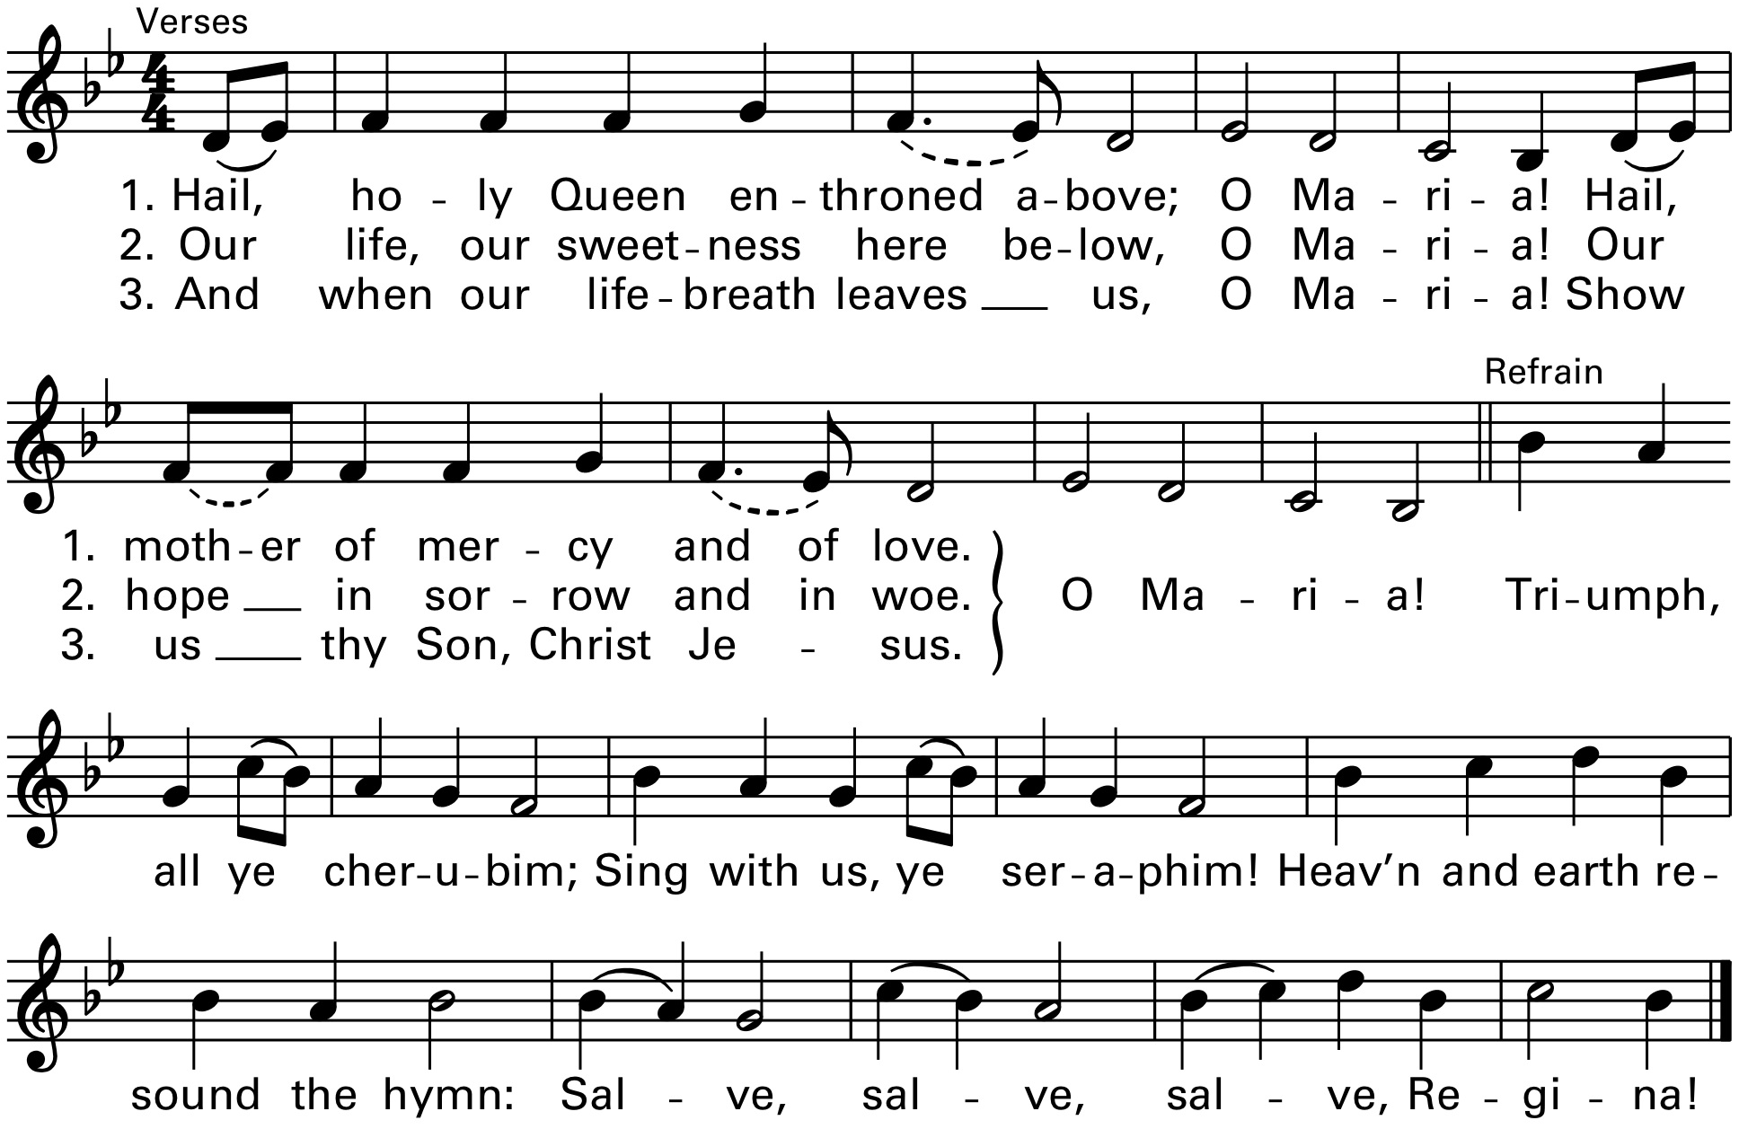

Closing Remarks

